Program 14: C Program to Organise Files Using a Single-Level Directory
Code:
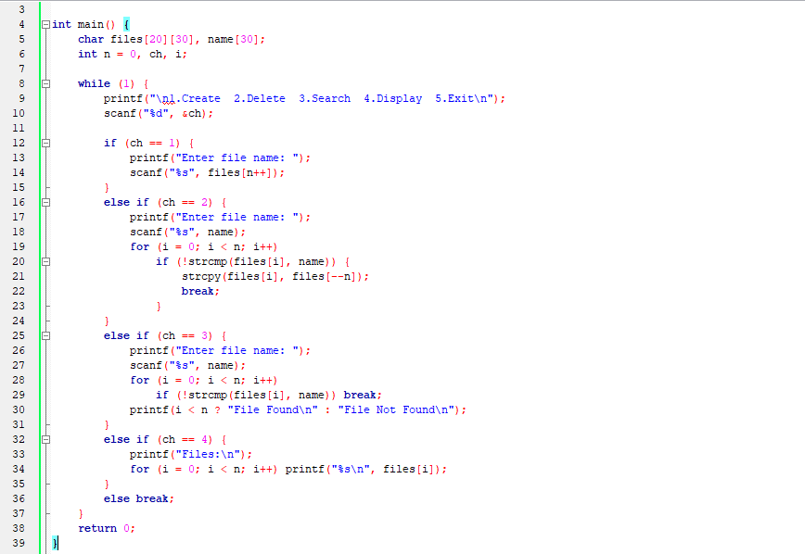
Output:
